CATHOLIC CENTRAL HIGH SCHOOL

ACADEMIC AWARDS

Catholic Central High School hosts an annual academic awards ceremony usually in mid-October. In general, the school’s awards policy is designed to encourage every student to be the best he or she can possibly be. To this end, there are a number of occasions in the school year when awards are presented in different spheres of school activities. In spring, for example, awards are presented for athletic achievement. At another occasion, we highlight students who have given outstanding service. The academic awards ceremony then has to be seen in the wider context of a wide-ranging awards program.

PHILOSOPHY

The Holy Spirit School Division recognizes the worth of each student in the eyes of Christ and seeks to develop the student’s potential to the fullest extent possible. Catholic Central High School has attempted to develop an awards policy that is consistent with this central philosophy, that promotes the objectives of a sound Catholic education, and that provides an incentive for and recognition of student effort and achievement.

The criteria for awards and scholarships are designed to recognize and reward the most deserving students in all areas of our curricular program. We have attempted to avoid an elitist approach by making it possible for any student to aspire to achieve distinction in one area or more.

At the same time, it is also our belief that an outstanding student who achieves highly in a number of areas should not be denied the recognition that he or she deserves.

FUNDING

All awards are funded by community organizations or individuals with the exception of the Rutherford Scholarships that are funded by the Government of Alberta. In addition, a CCHS Trust Fund has been established with its main objective being the funding of awards and scholarships as and when necessary. A tax exemption receipt is available on request for all donations.

It should be noted that because of funding, scholarships and awards are subject to change or withdrawal and the criteria and other details may change from year to year. Also, the Awards Committee reserves the right to withhold an award in any given year if in their opinion no candidate meets the criteria for the award.

ACADEMIC AWARDS COMMITTEE

The Academic Awards Committee is generally responsible for all matters pertaining to school awards and scholarships. It supervises the arrangements for the annual Awards Ceremony, arranges for the funding for school awards, and selects the recipients for awards on the basis of the criteria for each award.

The committee is responsible to the Principal and consists of an Associate Principal and/or Academic Guidance Counsellor who acts as chairman, and two faculty representatives. It is assisted in its function by the counselling secretary and the school’s accounts clerk. Where necessary, the committee will seek nominations from members of staff.

ACADEMIC AND LEADERSHIP AWARDS

Catholic Central High School recognizes the achievements of students in academic and leadership areas in several ways. The diagram below summarizes the basic policy on which these awards are made.

TOP AWARDS AND SCHOLARSHIPS
- value over $100.00
- leadership qualities
- top academic achievement
- provision for future scholarship

MIDDLE AWARDS
- value between $50.00 and $100.00
- general areas
- departmental awards

ACHIEVEMENT AWARDS
-certificates, plaques, honor pins
-specific courses
-recognition of effort/achievement in specific areas

VALEDICTORIAN

Perhaps the single greatest distinction that a student can earn in his/her career at school is the honor of being selected as Valedictorian of the graduating class. The selection has no monetary value but is the traditional manner in which outstanding academic ability and future potential is recognized by post-secondary institutions.

The Valedictorian’s chief duty is to deliver the valedictory address during the annual Graduation exercises. While the valedictory address is a personal expression, it is also expected to represent the collective philosophy and thinking of the class, a reflection of its achievements, and a statement of its aspirations for the future. To be eligible for consideration for this designation
Students must demonstrate leadership and service to the school community and provide service to the community at large. The selection is based on the straight average achieved by the student on the following criteria:

- Religious Education 35 or highest level of Religious Education completed to this date.

- Any four of the following:

Mathematics 30  Mathematics 31  English 30-1  Biology 30 | Chemistry 30  French Language Arts 30-1  Physics 30  Social Studies 30-1

Calculations for academic courses in quarters one and two will be based on final blended marks. Calculation for academic courses in quarter three will be based solely on school awarded marks. All courses will have to be taken at Catholic Central High School or through Trinity Learning Center.
ALEXANDER RUTHERFORD SCHOLARSHIPS

These scholarships are awarded annually by the Government of Alberta from the Heritage Fund. The criteria are:

NOTE:
Please note that students who are eligible for Rutherford Scholarships at any or all grade levels apply in their final high school semester (usually in May). The scholarships are only available when the student’s acceptance at an institution of further education (college or university) is confirmed by that institution.

Application are accessed online.
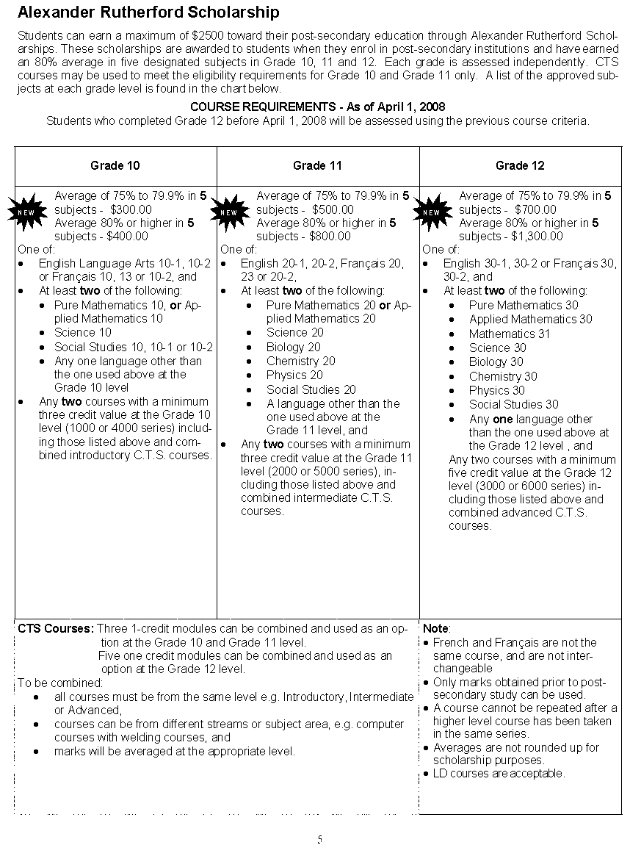

Specific Criteria for the Various Categories of Awards

HONOR CERTIFICATES

Donor: Catholic Central School Council

Criteria

Grade 10 A final average of 85% or higher in Religious Education 15, English 10-1 or 10-2, and four of the following courses in one school year taken at Catholic Central or through Trinity Learning Center. **Classes must be taken from September - June with the exception of approved summer school courses. Only one grade 11 core subject may be counted.

Math 10C or Math 10-3 Physical Education 10
French Language Arts 10 Science 10
Social 10-1 or Social 10-2 Science 14

Grade 11 A final average of 85% or higher in Religious Education 25, English 20-1 or 20-2, and four of the following courses in one school year taken at Catholic Central or through Trinity Learning Center. **Classes must be taken from September - June with the exception of approved summer school courses. Only one grade 12 core subject may be counted.

Biology 20 Chemistry 20
Math 20-1, 20-2, or 20-3 French Language Arts 20 Science 24 Science 20
Social 20-1 or Social 20-2 Physics 20
Physical Education 20

Grade 12 A final average (including diploma exams) of 85% or higher in Religious Education 35, English 30-1 or 30-2, and four of the following courses in one school year taken at Catholic Central or through Trinity Learning Center. **Classes must be taken from September - June with the exception of approved summer school courses.

Biology 30 Chemistry 30
Math 30-1, 30-2, or 30-3 Math 31
French Language Arts 30 Physical Education 30
Science 30 Social 30-1 or Social 30-2
Physics 30

ACHIEVEMENT CERTIFICATES

Criteria: An achievement certificate is awarded in each course taught in the school year to the student achieving the highest mark in the course. Students achieving the highest mark in four or more courses are awarded a plaque.

Achievement Certificates are sponsored by Knights of Columbus Council 5726
and Knights of Columbus Council 1490.

C.C.H.S. DEPARTMENTAL AWARDS

Criteria: These are awards made at the departmental level at the discretion of the Awards Committee to recognize a high level of achievement but not necessarily the highest mark in the designated area. These awards are usually made to Grade 12 students but in exceptional circumstances, students of other grades may be recognized.

DEPARTMENT DONOR AMOUNT

ART Ferrari, Westwood, Babits Architects $100

BIOLOGY Mr. William Kolysher & Family $200

CHEMISTRY Kiwanis Club of Green Acres $100

DRAMA Kiwanis Club of Green Acres $100

ENGLISH Kiwanis Club of Green Acres $100

FOOD STUDIES Kiwanis Club Green Acres $100

FRANÇAIS LANGUE SECONDE Kiwanis Club of Green Acres $100

KNOWLEDGE & EMPLOYABILITY Cal O’Brien Memorial Fund $100

LANGUE FRANÇAISE Kiwanis Club of Green Acres $100

MATHEMATICS Mr. Ludvik and Danica Pahulje $100

MATHEMATICS 20 The Lethbridge Institute of $85
Chartered Accountants of Alberta
MUSIC – CONCERT/CHORAL CCH Music Parents Association $50

MUSIC – INSTRUMENTAL MUSIC Weiler Family $100
Fred Weiler Memorial Award
MUSIC – SHOW CHOIR CCH School Council $100

NEW MEDIA Kiwanis Club of Green Acres $100

PHYSICAL EDUCATION CCH School Council $100

PHYSICS Cal O’Brien Memorial Fund $100
The Father Keon Award
RELIGIOUS EDUCATION CCH School Council $100

SOCIAL STUDIES Class of 1964 50th Reunion $100
Dr. R. G. (Bob) Koep Memorial Award
REGISTERED APPRENTICESHIP Beresnak Family $300
PROGRAM Douglas Beresnak Memorial Award
TRADES TECHNOLOGY Open Circle $300

WORK EXPERIENCE B’Nai Brith Lodge $500

ACHIEVEMENT AND LEADERSHIP SCHOLARSHIPS AND AWARDS

The following awards and scholarships recognize outstanding achievement. Any faculty member can nominate students and the Awards Committee makes the selection.

Highly Commendable Scholastic Effort $700
(Seven awards of $100 each)

Donors:
St. Martha’s Knights of Columbus Council #9280 ($300)
St. Patrick’s Knights of Columbus Council #10547 ($300)
Jozef and Theresa Prozniak ($100)

Criteria: Grade 12 students whose achievements are especially commendable for great effort. This award is presented to the fourth to tenth highest marks in grade 12.

1st Choice Savings Star Citizen Award $500

Donor: 1st Choice Savings

Criteria: This award is given to a student on the basis of dependability, cooperative spirit, leadership, service to their school and community, and evidence of personal value with integrity.

Susan Hurkens Memorial Award $100

Donor: The Weiler Family

Criteria: An Inclusive Education student whose achievements are especially commendable for great effort and/or progress in overcoming difficulties.

CUPE 1825 Diverse Learner Award $150

Donor: CUPE 1825

Criteria: The award is for highest achievement/ gain throughout the year in Inclusive Education for a coded student and is to be decided upon by the Inclusive Education teachers in consultation with Educational Assistants.

Suzanne Lint Award $100

Donor: Suzanne Lint

Criteria: This award recognizes commendable achievement in the Trinity Learning Centre Program. Students receiving this award have shown dedication, perseverance, and commitment to their education in a non-traditional environment.

Academic/ Track and Field $100

Donor: Runner’s Soul

Criteria: High Academic achievement by a Grade 12 student who was a member of the Track and Field team.

Cougar Women’s Basketball Scholarship $100

Donor: Cougar Basketball Club

Criteria: This scholarship is given to a graduating female basketball player who will be receiving post-secondary education.

Yates Scholarship for the Fine Arts $100 (Two awards of $50 each)

Donor: The Genevieve Yates Foundation

Criteria: Students who have achieved highly in one or more of the Fine Arts
areas and have shown indication of proceeding to further studies
in related areas.

CCH Music Parents Choral Music Award $50

Donor: CCH Music Parents Association

Criteria: Student with the highest achievement and excellent participation
in the Choral Music Program.

CCH Music Parents Instrumental Music Award $100

Donor: CCH Music Parents Association

Criteria: Student with the highest achievement and excellent participation
in the Instrumental Music Program.

Musical Theatre Award $200

Donor: CCH School Council

Criteria: This award is given to a student who has shown passion, selflessness, and fun in the CCS musical production. The recipient is selected by the Fine Arts department.

Amber Yamashita Memorial Award $200

Donor: Yamashita Family

Criteria: This award is given to a student who is planning to pursue further
studies in the fine arts. The recipient is selected by the Fine Arts Department.

Joe Feller Musical Theatre Award $200

Donor: Mrs. Pat Kensley

Criteria: Awarded to a student who has a love for the Fine Arts and
participated in the Musical Production in a “behind-the-scenes”
capacity. The recipient is selected by the Fine Arts Department.

St. Basil’s Parish Award $500

Donor: St. Basil’s Catholic Women's League

Criteria: Grade 12 student who has been an active parishioner in any local parish. The intent of the scholarships is to encourage parishioners in the pursuit of further academic excellence while also maintaining an active faith involvement in their parish.

Knights of Columbus Essay Contest $1000 split 3 ways

Donor: Knights of Columbus Council 5726

Criteria: This scholarship will be awarded to a Grade 10, 11, or 12 student with demonstrated involvement in leadership, athletics, arts, volunteerism, or service who writes a 1000-word essay about the mission and goals of the Knights of Columbus.

Sandra White Registered Nursing Award $500

Donor: Phyllis and Ray White

Criteria: The Sandra White Registered Nursing Award was established by Phyllis and Ray White in memory of their daughter. Sandra was a loving, enthusiastic, and passionate RN at Chinook Regional Hospital for close to 30 years. In her memory, this scholarship will be awarded to a Grade 12 student who exemplifies passion for the nursing profession, and will be entering into a Post-Secondary Registered Nursing Program.

Rotary Club Citizenship Award $500

Donor: Rotary Club of Lethbridge

Criteria: A student with a good academic record combined with outstanding leadership and community service.

St. Joseph Award $500

Donor: Darren Trempner

Criteria: This award will be offered to a grade 12 student in the -2 and/or -3 stream who has demonstrated excellent work ethic, humility, a positive attitude when faced with difficulties, and care and support of others.

Premier’s Citizenship Award Letter of Commendation from Gov. of Alberta

Letter of Commendation: Government of Alberta

Criteria: Excellent academic record combined with outstanding leadership and community service.

Mirella Zappone Social Justice Award $200

Donor: Mirella Zappone Endowment Fund

Criteria: This award is given to a student who has overcome adversity or oppression in his or her previous place of residence.

Kimberly Oliverio Memorial Scholarship $1000

Donor: Vittorio, Kathy, and Cara Oliverio

Criteria: The Kimberly Oliverio Memorial Scholarship was established by the Oliverio family to honor the memory of their daughter Kimberly, an alumna of Catholic Central High School who graduated in 2007. Kimberly died in a car accident in February of 2016. She is remembered for her loving and amiable personality, her sense of responsibility, and, most significantly, as a person who lovingly shared her own gifts by helping those around her. Kimberly had furthered her studies at the university level, later graduating from the University of Lethbridge in Business. She had been actively involved in athletics and leadership and community service. The Oliverio family generously donates this scholarship in memory of the legacy of Kimberly. Candidates for the scholarship: ● Will be in grade 12, with an academic average of 75% or higher (may be given to grade 10 or 11 students with outstanding leadership and service); ● Will have been involved in the school’s Athletic Leadership Program; ● Will have participated as a volunteer in his/her community and have demonstrated a positive attitude towards others; ● Will be enrolled in a post-secondary institute at the college or university level; and ● Will be selected by the Athletic Leadership Department.

Banditos Incorporated Welding Award $500 Gift Card

Donor: Banditos Incorporated
Criteria: This scholarship will be awarded annually to a student who:
- has shown exemplary performance in the Welding & Fabrication program at Catholic Central High School in both theoretical and practical applications
- has taken 2 or more sections of Welding & Fabrication at Catholic Central High School
- has a visible passion for the trades, specifically Welding & Fabrication
- is pursuing post-secondary studies in the Welding field..

Highest Achievement in Grade 10 $150

Donor: CCH School Council

Criteria: The student with the highest final average in Religious Education 15, English 10-1 or 10-2, and 20 credits at the Grade 10 level or higher.

Highest Achievement in Grade 11 $150

Donor: Holy Spirit Catholic Teachers A.T.A. Local #5

Criteria: The student with the highest final average in Religious Education 25, English 20-1 or 20-2, and 20 credits at the Grade 11 level or higher.

Stan Sawicki Award for 3rd Highest Achievement in Grade 12 $150

(One Award) )

Donor: Catholic Central School Council

Criteria: The student with the third highest final average in Religious Education 35, English 30-1 or 30-2, and any three other diploma examination courses at the Grade 12 level.

Second Highest Achievement in Grade 12 $250

(One Award)

Donor: Vera and Albert Kenwood

Criteria: The student with the second highest final average in Religious Education 35, English 30-1 or 30-2, and any three other diploma examination courses at the grade 12 level at Catholic Central or through Trinity Learning Center.

Highest Achievement in Grade 12 $500

(One award)

Donor: Vera and Albert Kenwood

Criteria: The student with the highest straight average in Religious Education 35, English 30-1 or 30-2, and any three other diploma examination courses at the Grade 12 level at Catholic Central or through Trinity Learning Center.

GOVERNOR GENERAL AWARD – BRONZE MEDAL PRESENTATION
Donor: Government of Alberta – Bronze Medal

Criteria: The students with the highest straight average in Religious Education 35, English 30-1 or 30-2, and any three other diploma examination courses at the Grade 12 level at Catholic Central or through Trinity Learning Center.

Lethbridge Parishes’ Scholarships

St Martha’s Parish offers one scholarship of $250 annually to a
graduating Grade 12 student of Catholic Central High School who has been an
active parishioner. High academic achievement is one of the criteria
considered by the committee, but the award is not necessarily made to the
highest achiever from the parish. The intent of the scholarships is to
encourage parishioners in the pursuit of further academic excellence while
also maintaining an active faith involvement in their parish.

St Basil’s CWL offers one scholarship of $500.00 annually to any graduating
Grade 12 student of Catholic Central High School who as been an active
parishioner in any local parish. The intent of the scholarships is to
encourage parishioners in the pursuit of further academic excellence while
also maintaining an active faith involvement in their parish. Academic
achievement is only one of the many criteria considered by the committee.

St. Basil’s Church Parish

Donor: St. Basil’s Catholic Women’s League

St. Martha’s Church Parish

Donor: St. Martha’s Parish Council

Application forms are available from the counsellor.

Deadline: June 30

Kd/f:admin/data/booklets/award booklets

APPLICATION FOR A PARISH AWARD

Applicant’s Name: __________________________________________________________
(Please print) First Middle Last

Parish: ____________________________________________________________________

Applicant’s Address: _______________________________________________________

Postal Code: ________________ Home Telephone Number: ____________________

University/College applied to: ______________________________________________

School activities you were involved in: ______________________________________

____________________________________________________________________________

____________________________________________________________________________

Community activities you were involved in: __________________________________

Church or parish activities you were involved in:

_____________________ ______________________________
Date Applicant’s Signature

Together with this application, please submit the following:

- A transcript of Grade 10-12 course, (obtainable from the school).
- A sealed letter of recommendation from one of your teachers or other school officials.
- A sealed letter of recommendation from a member of the parish who knows you or your family well.

Deadline: June 30
MAILING INSTRUCTIONS

This completed application form and the supporting documents are to be sent to ONE of the following, depending on your parish.

- Applicants from Assumption Parish

The Scholarship Committee
Assumption Catholic Women’s League
Our Lady of the Assumption Church
2405-12 Ave. S.
Lethbridge, AB.
T1K 0P4

- Applicants from St. Basil’s Parish

The Scholarship Committee
St. Basil’s Catholic Women’s League
St. Basil’s Church
604-13 St. N.
Lethbridge, AB.
T1H 2S8

- Applicants form St. Martha’s Parish

The Scholarship Committee
St. Martha’s Parish
164 Laval Blvd. W.
Lethbridge, AB.
T1K 4E5

- Applicants from St. Patrick’s Parish

The Scholarship Committee
St. Patrick’s Parish Council
St. Patrick’s Church
318-10 St. S.
Lethbridge, AB.
T1J 2M6

Deadline: June 30

Parish Awards
Each of the above parishes offers one scholarship of $250.00 annually to a graduating Grade 12 student of Catholic Central High School who has been an active parishioner. High academic achievement is one of the criteria considered by the committee but the award is not necessarily made to the highest achiever from the parish. The intent of the scholarship is to encourage parishioners in the pursuit of further academic excellence while also maintaining an active faith involvement in their parish.

FOR COURAGE

Lord Jesus, teach me to be generous;
Teach me to serve you as you deserve,
To give and not to count the cost,
To fight and not to heed the wounds,
To toil and not to seek for rest,
To labor and not to seek reward,
Except that of knowing that I do your will,
Amen.

-St. Ignatius Loyola-

